https://www.amazon.com/Cooper-Bussma...ircuit+breaker

Blinking light at the breaker panel (2-part question)
The LED is showing you what state that your Progressive Dynamics charger is in. The button near it can be used to somewhat control the charger.
From Progressive literature:
While the built-in Charge Wizard automatically determines which operating mode is best suited to recharge or
maintain optimum battery condition, the Remote Pendant allows for manual override and has an indicator light(s) to
indicate the mode of operation.
BOOST MODE – Indicated by green LED remaining on. The output voltage is 14.4VDC to rapidly recharge the
battery up to 90% of full charge.
NORMAL MODE – When the battery is between 50% and 90% charged, the green LED will flash once per
second. When the battery has reached 90% of full charge the green LED will flash 2 - 3 times per second. In this
mode the output voltage is 13.6VDC and the converter is safely completing the charge of the battery.
STORAGE MODE – Indicated by green LED flashing every 6 - 8 seconds. In this mode the output voltage has
been lowered to 13.2VDC, the RV battery is fully charged and the converter is maintaining the charge.
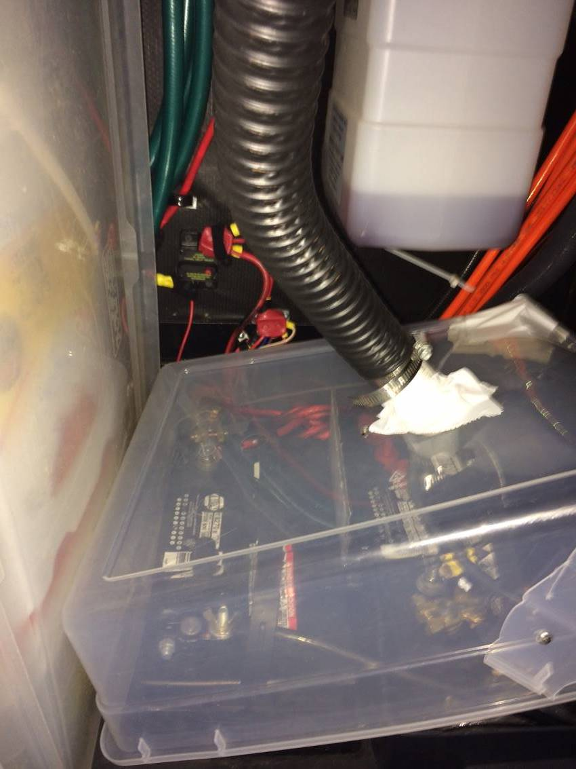
MANUAL BUTTON - The manual button has been provided to allow the operator to temporarily override the
converter (not recommended) or to verify the converter is operating properly. For manual operation, Press and Hold
the button. The indicator light will soon remain “ON” indicating Boost Mode. Continue to hold the button and the
light will blink rapidly indicating the converter is in the Normal Mode. Continue to hold the button until the light
blinks slowly indicating the converter is now in the Storage Mode. After the manual button is released the converter
will stay in the selected mode. When the battery charge status changes, the converter will return to the automatic
mode of operation to prevent damage to the battery.

If the slide outs periodically stop or
Stabilizers don’t work, reset the manual
80 amp breaker (replaced 50amp ‘auto reset – fkd)

